***Федеральное государственное бюджетное образовательное учреждение высшего профессионального образования***

|  |  |
| --- | --- |
|  | ***«Московский государственный технический университет  имени Н.Э. Баумана»***  ***(МГТУ им. Н.Э. Баумана)*** |

**Факультет ИУ**

**Кафедра ИУ10**

**Отчет**

**по лабораторной работе № 3**

**Дисциплина: Языки программирования**

**Тема: «Git и GitHub»**

Работу выполнил: Аникин Артём Дмитриевич ИУ 10-24

Проверил: Буркацкий Кирилл Александрович

Москва, 2024

**Цель работы:** научиться пользоваться циклами и функциями

**Ход работы**

Задача №1

*Цель:* Сделать угрюмый смайлик

*Ход решения задачи*

* Написание программы

import pygame  
from sys import exit  
  
pygame.init()  
  
display = pygame.display.set_mode( (800, 600) )  
display.fill((255,255,255))  
  
  
pygame.draw.circle( display, (255, 255, 0) , (400,250), 200)  
pygame.draw.circle( display, (255,0,0) , (500,200), 25)  
pygame.draw.circle( display, (0,0,0) , (500,200), 15)  
pygame.draw.circle( display, (255,0,0) , (300,200), 35)  
pygame.draw.circle( display, (0,0,0) , (300,200), 20)  
pygame.draw.polygon( display, (0, 0, 0) , ( (500, 400), (500, 370), (300, 370), (300, 400) ) )  
pygame.draw.polygon( display, (0, 0, 0) , ( (445, 180),(450, 190), (600, 140), (595, 130) ) )  
pygame.draw.polygon( display, (0, 0, 0) , ( (390, 205), (395, 190), (195, 100), (190, 115) ) )  
FPS = 60  
clock = pygame.time.Clock()  
while True:  
 for event in pygame.event.get():  
 if event.type == pygame.QUIT:  
 pygame.quit()  
 exit()  
  
 pygame.display.update()  
  
 clock.tick(FPS)

Результат:

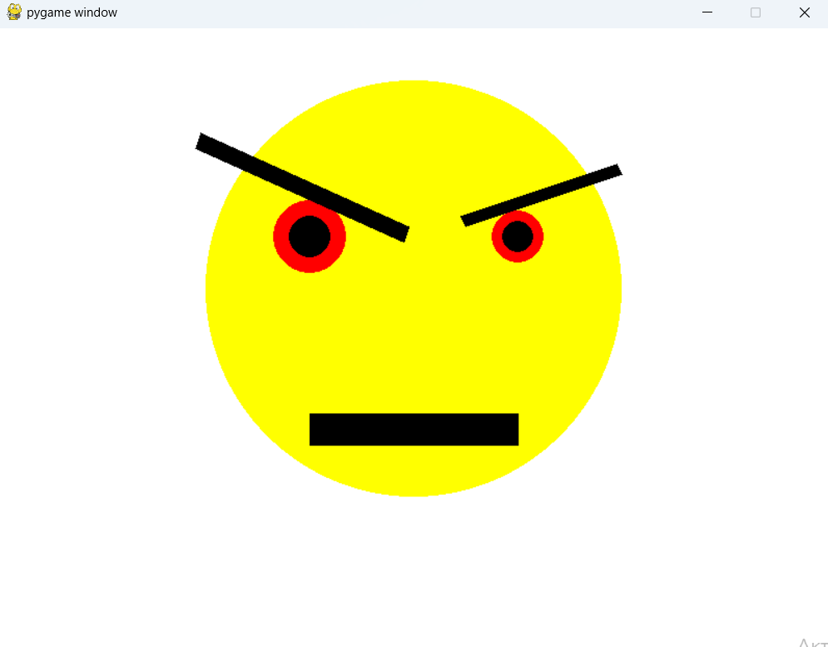

Задача №2

*Цель:* Сделать изображение:

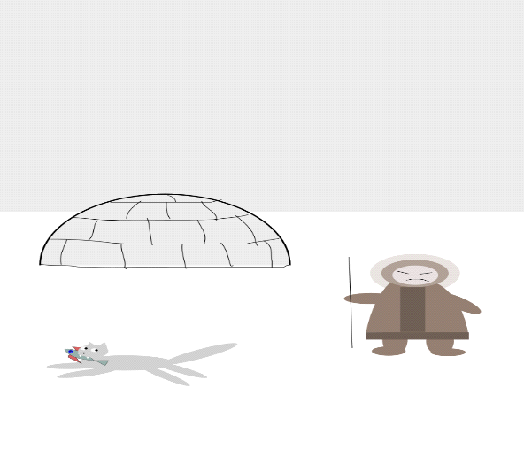

*Ход решения задачи*

* Написание программы
* Код

import pygame  
from pygame.draw import *  
pygame.init()  
def rec(a,b,c,d,e,f,g):  
 rect(screen,(a,b,c),(d,e,f,g))  
FPS = 30  
screen = pygame.display.set_mode((400, 400))  
screen.fill((255,255,255))  
polygon(screen,(112,112,112),((0,0 ),(400,0),(400,200),(0,200)))  
def ell(a,b,c,d,e,f,g):  
 ellipse(screen, (a,b,c), (d,e,f,g))  
def nakl(n,y,z,l):  
  
 color = (128, 128, 128)  
 for i in range(15):  
 ellipse(screen, color, (n+125, y+205,10, 10))  
 n+=1/z  
 y+=1/l  
  
pi=3.14  
def arc(a,b,c,d,e,f,g,h,j,n):  
 pygame.draw.arc(screen,(a,b,c),(d,e,f,g),h,j,n)  
resu=arc(192, 192, 192,50,190,140,140,0,pi,150)  
resu=arc(0,0,0,50,190,140,140,0,pi,2)  
aalines(screen,(0,0,0),False,[(50,260),(60,255),(75,256),(80,254),(110,254),(120,255),(150,260),(190,260)])  
aalines(screen,(0,0,0),False,[(52,240),(72,245),(97,246),(115,244),(130,244),(150,246),(162,249),(186,240)])  
aalines(screen,(0,0,0),False,[(59,220),(90,224),(100,226),(115,221),(130,222),(160,224),(178,225)])  
line(screen,(0,0,0),(75,210),(75,260))  
line(screen,(0,0,0),(95,190),(95,260))  
line(screen,(0,0,0),(130,190),(130,260))  
  
r2=ell(128, 128, 128,190,300,55,25)  
n=(nakl(100,110,4/3,4/3))  
n=(nakl(114,110,4/3,4/3))  
n=(nakl(114,110,4/3,4/3))  
n=(nakl(114,95,-4/3,-4/3))  
n=(nakl(72,122,4/3,-4/3))  
n=(nakl(58,122,4/3,-4/3))  
r2=ell(128, 128, 128,180,290,25,25)  
polygon(screen,(128, 128, 128),((200,285 ),(195,297.5),(205,297.5)))  
polygon(screen,(128, 128, 128),((185,285 ),(180,297.5),(190,297.5)))  
r2=ell(255, 255, 255,185,295,5,5)  
r2=ell(255, 255, 255,195,295,5,5)  
r2=ell(0,0,0,186,297,2,2)  
r2=ell(0,0,0,196,297,2,2)  
r2=ell(0,0,0,190,300,2,2)  
r2=ell(0,0,255,175,305,25,5)  
r2=ell(255,0,0,178,305,3,3)  
polygon(screen,(165, 42, 42),((180,305 ),(180,303),(185,303)))  
polygon(screen,(165, 42, 42),((180,310 ),(180,308),(185,308)))  
polygon(screen,(0,0,255),((190,307),(205,310),(205,304)))  
polygon(screen,(255,255,255),((185,305 ),(186,307),(187,305)))  
polygon(screen,(255,255,255),((194,305 ),(195,307),(196,305)))  
  
r1=ell(245, 222, 179,295,265,60,40)  
line(screen,( 0,0,0),(285,275),(275,335),1)  
r2=ell(183, 143, 143,280,300,30,15)  
r2=ell(183, 143, 143,345,300,30,15)  
r2=arc(183, 143, 143,285,295,80,80,0,pi,40)  
line(screen,( 139, 69, 19),(323,300),(323,335),10)  
r1=ell(183, 143, 143,300,270,50,30)  
r1=ell( 255, 210, 190,305,275,40,20)  
line(screen,( 0,0,0),(312,280),(317,283),1)  
line(screen,( 0,0,0),(332,283),(337,280),1)  
r2=arc(0,0,0,315,290,10,5,pi/9,pi,1)  
r2=ell(183, 143, 143,280,300,30,15)  
r2=ell(183, 143, 143,295,320,15,30)  
r2=ell(183, 143, 143,340,320,15,30)  
line(screen,( 139, 69, 19),(285,335),(365,335),10)  
r2=ell(183, 143, 143,285,345,20,5)  
r2=ell(183, 143, 143,345,345,20,5)  
  
pygame.display.update()  
clock = pygame.time.Clock()  
finished = False  
  
while not finished:  
 clock.tick(FPS)  
 for event in pygame.event.get():  
 if event.type == pygame.QUIT:  
 finished = True  
  
pygame.quit()

Результат:

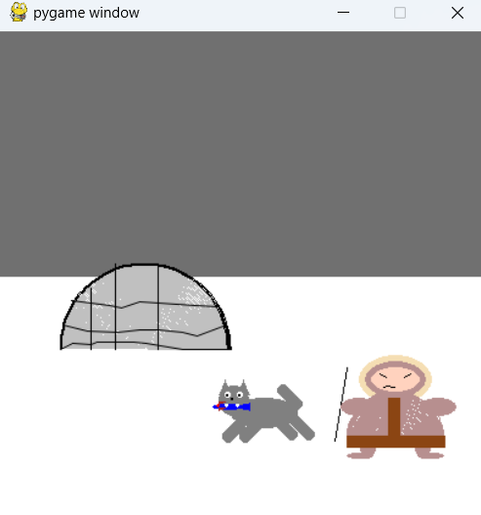

Задача №3

*Цель:* Сделать изображение

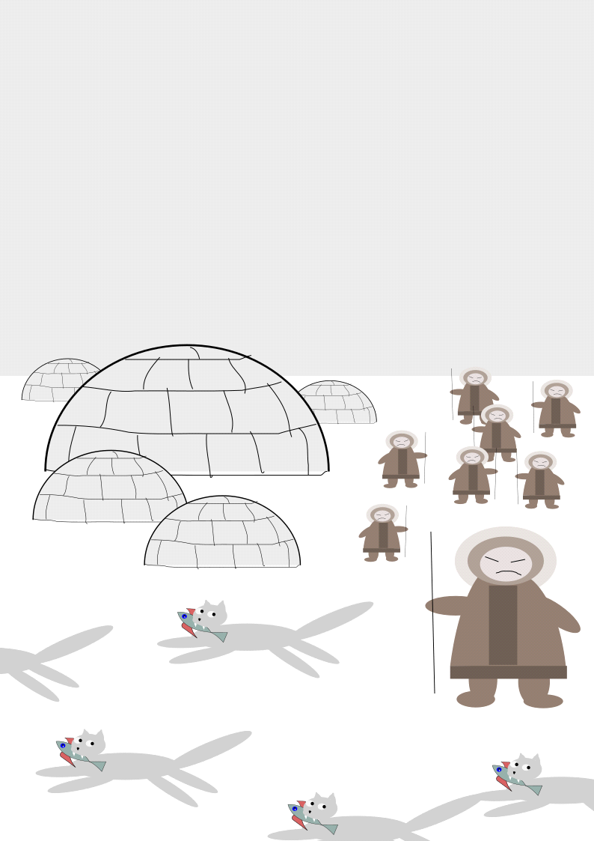

*Ход решения задачи*

* Написание программы

import pygame  
from pygame.draw import *  
pygame.init()  
def rec(a,b,c,d,e,f,g):  
 rect(screen,(a,b,c),(d,e,f,g))  
FPS = 30  
screen = pygame.display.set_mode((400, 400))  
screen.fill((255,255,255))  
polygon(screen,(112,112,112),((0,0 ),(400,0),(400,200),(0,200)))  
def ell(a,b,c,d,e,f,g):  
 ellipse(screen, (a,b,c), (d,e,f,g))  
def nakl(n,y,z,l):  
  
 color = (128, 128, 128)  
 for i in range(15):  
 ellipse(screen, color, (n+125, y+205,10, 10))  
 n+=1/z  
 y+=1/l  
  
pi=3.14  
def arc(a,b,c,d,e,f,g,h,j,n):  
 pygame.draw.arc(screen,(a,b,c),(d,e,f,g),h,j,n)  
def yourta(x,p):  
 arc(192,192,192,50+x,190+p,140,140,0,pi,150)  
 arc(0,0,0,50+x,190+p,140,140,0,pi,2)  
 aalines(screen,(0,0,0),False,[(50+x,260+p),(60+x,255+p),(75+x,256+p),(80+x,254+p),(110+x,254+p),(120+x,255+p),(150+x,260+p),(190+x,260+p)])  
 aalines(screen,(0,0,0),False,[(52+x,240+p),(72+x,245+p),(97+x,246+p),(115+x,244+p),(130+x,244+p),(150+x,246+p),(162+x,249+p),(186+x,240+p)])  
 aalines(screen,(0,0,0),False,[(59+x,220+p),(90+x,224+p),(100+x,226+p),(115+x,221+p),(130+x,222+p),(160+x,224+p),(178+x,225+p)])  
 line(screen,(0,0,0),(75+x,210+p),(75+x,260+p))  
 line(screen,(0,0,0),(95+x,190+p),(95+x,260+p))  
 line(screen,(0,0,0),(130+x,190+p),(130+x,260+p))  
yourta(0,0)  
yourta(50,10)  
yourta(100,20)  
yourta(0,50)  
def cat(t,k):  
 r2=ell(128, 128, 128,190+t,300+k,55,25)  
 n=(nakl(100+t,110+k,4/3,4/3))  
 n=(nakl(114+t,110+k,4/3,4/3))  
 n=(nakl(114+t,110+k,4/3,4/3))  
 n=(nakl(114+t,95+k,-4/3,-4/3))  
 n=(nakl(72+t,122+k,4/3,-4/3))  
 n=(nakl(58+t,122+k,4/3,-4/3))  
 r2=ell(128, 128, 128,180+t,290+k,25,25)  
 polygon(screen,(128, 128, 128),((200+t,285+k ),(195+t,297.5+k),(205+t,297.5+k)))  
 polygon(screen,(128, 128, 128),((185+t,285+k ),(180+t,297.5+k),(190+t,297.5+k)))  
 r2=ell(255, 255, 255,185+t,295+k,5,5)  
 r2=ell(255, 255, 255,195+t,295+k,5,5)  
 r2=ell(0,0,0,186+t,297+k,2,2)  
 r2=ell(0,0,0,196+t,297+k,2,2)  
 r2=ell(0,0,0,190+t,300+k,2,2)  
 r2=ell(0,0,255,175+t,305+k,25,5)  
 r2=ell(255,0,0,178+t,305+k,3,3)  
 polygon(screen,(165, 42, 42),((180+t,305+k ),(180+t,303+k),(185+t,303+k)))  
 polygon(screen,(165, 42, 42),((180+t,310+k ),(180+t,308+k),(185+t,308+k)))  
 polygon(screen,(0,0,255),((190+t,307+k),(205+t,310+k),(205+t,304+k)))  
 polygon(screen,(255,255,255),((185+t,305+k ),(186+t,307+k),(187+t,305+k)))  
 polygon(screen,(255,255,255),((194+t,305+k ),(195+t,307+k),(196+t,305+k)))  
cat(0,0)  
cat(0,50)  
cat(-100,0)  
cat(-190,-100)  
def people(q,w):  
 r1=ell(245, 222, 179,295+q,265+w,60,40)  
 line(screen,( 0,0,0),(285+q,275+w),(275+q,335+w),1)  
 r2=ell(183, 143, 143,280+q,300+w,30,15)  
 r2=ell(183, 143, 143,345+q,300+w,30,15)  
 r2=arc(183, 143, 143,285+q,295+w,80,80,0,pi,40)  
 line(screen,( 139, 69, 19),(323+q,300+w),(323+q,335+w),10)  
 r1=ell(183, 143, 143,300+q,270+w,50,30)  
 r1=ell( 255, 210, 190,305+q,275+w,40,20)  
 line(screen,( 0,0,0),(312+q,280+w),(317+q,283+w),1)  
 line(screen,( 0,0,0),(332+q,283+w),(337+q,280+w),1)  
 r2=arc(0,0,0,315+q,290+w,10,5,pi/9,pi,1)  
 r2=ell(183, 143, 143,280+q,300+w,30,15)  
 r2=ell(183, 143, 143,295+q,320+w,15,30)  
 r2=ell(183, 143, 143,340+q,320+w,15,30)  
 line(screen,( 139, 69, 19),(285+q,335+w),(365+q,335+w),10)  
 r2=ell(183, 143, 143,285+q,345+w,20,5)  
 r2=ell(183, 143, 143,345+q,345+w,20,5)  
people(0,0)  
people(-100,0)  
people(0,-100)  
pygame.display.update()  
clock = pygame.time.Clock()  
finished = False  
  
while not finished:  
 clock.tick(FPS)  
 for event in pygame.event.get():  
 if event.type == pygame.QUIT:  
 finished = True  
  
pygame.quit()

Результат:

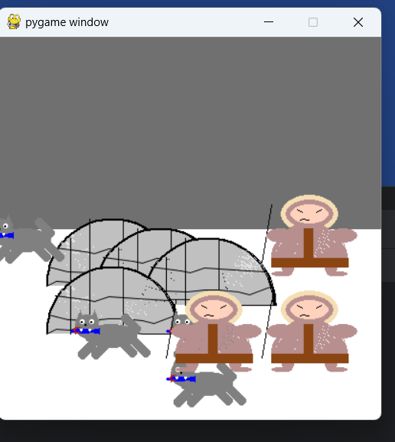

Вывод: таким образом, мы на библиотеке “Pygame” научились рисовать картинки